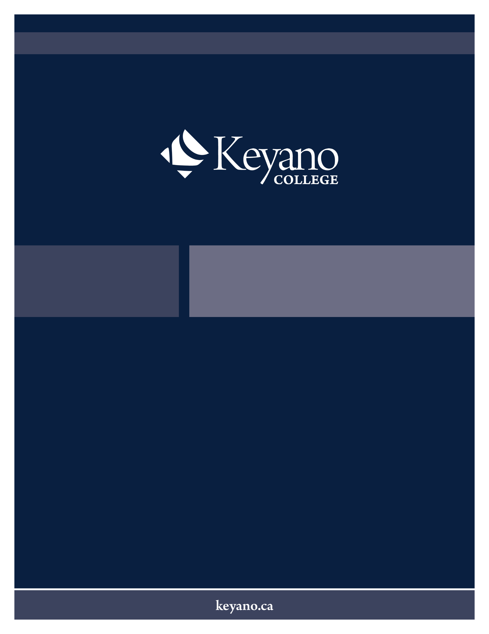
Course Outline
CYC 202
Child and Youth Mental Health & Addiction
Winter/2026/ABLD
CYC 202 – Child & Youth Metal Health & Addiction
3 credits, 45 hours
Course Description
This course introduces students to the complex issues of mental health and addiction significantly impacting children, youth, families and communities. These challenges are examined with emphasis upon evidenced-based practice, support, and treatment approaches. Students examine models and theories of addiction, attitudes and values toward substance use, and the complex relationship between mental health and addictions. The impact of attachment, trauma, resilience, and self-regulation will be explored as well as a basic overview of the common classes of psychoactive drugs, highlighting typical responses and common side effects within the context of the Child and Youth Care practice setting.
Pre-Corequisites
Prerequisite: CYC 100, CYC 101, CYC 102, CYC 103, CYC 104, ELCC 330
Course Learning Outcomes (CLOs)
Upon successful completion of the course, the student shall be able to:
- Describe how trauma impacts attachment.
- Integrate trauma/attachment theory into intervention plans.
- Discuss early indicators, behaviours, mood markers and influences of child and youth mental health in a variety of practice settings.
- Illustrate mental health behaviours and risks specific to adolescent development.
- Discuss mental health, suicide, and suicide prevention.
- Analyze the complex relationship between mental health and addictions.
- Develop an understanding of the role of a professional in the assessment, treatment and prevention of addiction, and the promotion of mental wellness in the lives of children, youth, families, and communities.
- Use evidence-based and evidence-informed research to support intervention plans, applying understanding of a variety of practice settings.
- Apply relational strategies, trauma-informed, and culturally sensitive practice to support children, youth, and families with mental health and/or addiction related needs.
- Explore various psychoactive drugs, along with common side effects and responses.

Assessment Type | Percentage
Assignments and Projects | 60%
Quizzes & Tests | 40%

Course Completion Requirements
A progression grade of C- is required.
Grading Scale
4.0 | A+ | 93-100
4.0 | A | 85-92.9
3.7 | A- | 80-84.9
3.3 | B+ | 77-79.9
3.0 | B | 74-76.9
2.7 | B- | 70-73.9
2.3 | C+ | 67-69.9
2.0 | C | 64-66.9
1.7 | C- | 60- 63.9
1.3 | D+ | 55-59.9
1.0 | D | 50-54.9
0.0 | F | 0-49

Land Acknowledgement
We respectfully acknowledge that Keyano College is located on Treaty 8 territory, the traditional and contemporary meeting grounds and gathering places of the Denesuline, Cree and Métis Peoples of this region. Our name, Keyano (kiyânaw in nêhiyawêwin – Cree language), translates to “we, us, our” and speaks to the connection we have as a community and our commitment to being in the right relationships with the First Peoples of these lands.
Review Date: July 2025
Every effort has been made to ensure that the information in this course outline is accurate at the time of publication. Keyano College reserves the right to change courses if necessary, so that course content remains relevant. In such cases, the instructor will give the students clear and timely notice of the changes.
Keyano College reserves the right to modify the syllabus, curriculum, or schedule of any course/program or to cancel a course/program entirely at any time and for any reason. Such changes may be necessary due to unforeseen circumstances, regulatory requirements, or to ensure the highest quality of education. Students will be notified of any significant changes as soon as possible. Keyano College is not responsible for any inconvenience or disruption caused by these changes. It is the students' responsibility to stay informed about any updates or modifications to their courses.
All Rights Reserved: No part of this course outline may be reproduced or resold without Keyano College's written permission.

