Remote Access at Keyano College
  - Prepared by: ITS
  - Description: This document outlines the use of VDI and VPN at Keyano College. Use cases include working on both personal and college devices.
  - Created: 2020-03-13
Table of Contents

Introduction 2
Technical Requirements 2
Must Read - VPN vs VDI 3
Should I use VDI or VPN? 3
Must Read - Outlook and File Security/Privacy 3
Using Outlook / Email 3
File security and privacy 3
Must Read – Student vs Staff Desktop 4
Remote Access on personal (Non-Keyano) devices 5
Remote Access on Keyano Devices (laptops) 7
Accessing VDI for the first time 8
Using the Virtual Desktop 9
Configuring and connecting using VPN 10

Introduction
The Virtual Desktop Infrastructure (VDI) system allows you to use your own device or a college laptop to connect to the college systems. It grants you access to business applications and resources you would typically use on campus. This includes software like MS Office suite, PowerCampus, Great Plains and resources like the Q Drive, connect, etc.
The VPN client (FortiGate VPN) allows you to connect a Keyano laptop to the Keyano network remotely.
Please make sure to read the sections titled “Must Read”

Technical Requirements

- The VDI client works on most types of computers, phones and tablets.
You will need one of the following to use the virtual desktop environment:
- Computer running
  - Windows 7, 8 or 10 (Windows 10 is recommended)
  - Mac OS X 10.13 and newer
  - ChromeOS
- Tablet or phone running Android (5.0+) or iOS (11.0+)
Essentially if you have a device you purchased in the last 4-5 years, your device is most likely supported.
- Updated Browser (Avoid Internet Explorer)
  - Firefox
  - Chrome
  - Edge
  - Safari
- A stable internet connection (Performance may vary on extremely slow connections).

Must Read - VPN vs VDI
There are some important considerations to help you chose between VPN and VDI.

Should I use VDI or VPN?
- Whenever possible, use VDI.
- Applications and access to resources (Q drive, PowerCampus, etc.) will be much slower over VPN.
- Only use VPN if you are using some specialized software that is not available to you on the VDI.
- Do not install VPN on your personal (non-Keyano) computer to connect to Keyano resources.
Do not use the VPN and VDI at the same time

Must Read - Outlook and File Security/Privacy

Using Outlook / Email
While MS Outlook is available on the VDI client, we highly recommend that you not use this.
Instead, use the link to Keyanomail (webmail) on your desktop. The webmail interface is quite close to that of Outlook and has most features that you need including the Calendar and contacts, notes etc.
If you have a Keyano laptop, we recommend using the outlook software on that device directly rather than through this VDI client.

File security and privacy
Avoid copying work related files directly on to your personal machine. This could be both a security and privacy concern. Attempt to use the files and resources within the VDI client itself.

Must Read – Student vs Staff Desktop
Users will have access to one or more desktops like shown below. Select the option that suits you best.
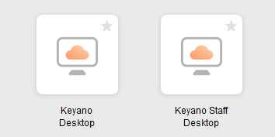
Student Desktop - This is designed to work like the computers that students and instructors would have in the computer labs. It grants you access to:
  - Course software like Sage
  - Full Office Suite
  - Personal “U” drive
  - Student “S” drive
  - Collaboration “Q” drive
NOTE: Any files saved here on the desktop, document, downloads or changes made by users, will disappear if you disconnect from the session. Files saved within the U, Q or S drive will be safe.

Staff Desktop - This is designed for use by employees who need specialized ERP software like PowerCampus, Great Plains, Clockwork, etc.
NOTE: Any files saved here, or changes made to this by users, will remain even if you disconnect. It is still recommended that you use the U or the Q drive to safely store files. There is however limited space available on here and it is we don’t recommend download large files (videos, applications etc.)
If you are missing software that you would need here, please contact the ITS helpdesk.

Remote Access on personal (Non-Keyano) devices
To access the VDI environment on your personal machine for the first time, follow these steps:
- Make sure you are connected to the internet
Open a recommended browser and navigate to:
https://desktop.keyano.ca/

Note: You have 2 options going forward.

Option 1: If you are an occasional user, continue with “VMware Horizon HTML Access”
Option 2: If you intend to use the VDI system often, choose to install the client. This is detailed on step 2.

For option 1, click on “VMware Horizon HTML Access” and sign in using your Keyano Credentials.
Once you sign in, skip ahead to section title “Using the Virtual Desktop”
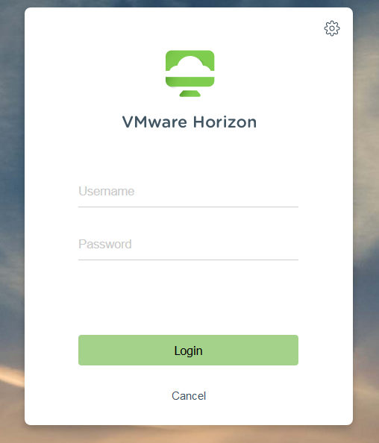

- For option 2,
You will be taken to a page to choose your operating system.
Click “Go to Download” beside the OS choice.
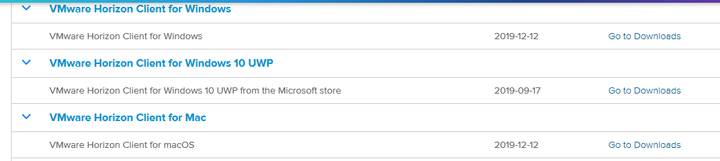
You will need administrative rights on your machine. Do not attempt this on a Keyano Laptop.
This step is only meant for users attempting to install this on their personal machine.
You will be required to restart your machine after this step.
- After downloading the installer, run it.
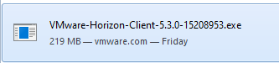
- You will be asked to accept the terms “Agree & Install”
- Wait for the process to complete and then click “Finish”. You will be asked to Restart.
Click “Restart Now”
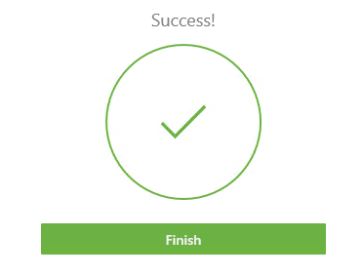
- Continue to section titled “Accessing VDI for the first time”.

Remote Access on Keyano Devices (laptops)
For regular use, please follow steps below.
Note: If you don’t have the client installed on your laptop, ask ITS for assistance.
Optionally, you may use the web client directly through a browser. This is outlined under “Option 1” under the section titled “Remote Access on personal (Non-Keyano) devices”.
- Launch the client
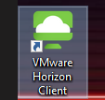
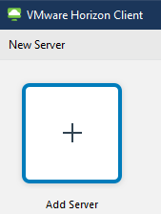 | If this is the first time you are using the client, you will see the following on screen.  Continue to the section titled “Accessing the VDI for the first time”.
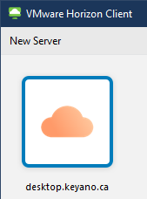 | If you have previously connected to the VDI using the client, you will see the following screen.  Continue to the section titled “Using the virtual Desktop”

Accessing VDI for the first time
These steps will be needed only the first time you run the client.
- Double click on the following “Add Server”
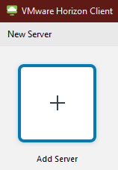
- Enter “desktop.keyano.ca” on the next window and click Connect.
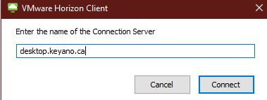
- You will be asked for your Keyano credentials
This will be your username and password that you use to sign into your computers at the college daily.
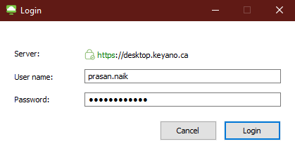
Enter your credentials and click login.
If you signed in successfully, you should see your desktop connectivity options next.
Follow the section titled “Using the Virtual Desktop”

Using the Virtual Desktop
- Select one of the options that you have available to you.
Once you have started the session through the Horizon client, it will open a full screen window.

Note the following menu bar at the top of the screen.
- To minimize this session and go back to your personal device, you can click the minimize window button on the menu (shown above).
- To close the session, click the close button on the same menu
- You can hide or permanently show this menu by clicking the “Pin” icon
If the menu is hidden, move your mouse to the top of the screen.

- You can now use this like any computer you would use while you were physically at work. For example, you can access the network drives (Q Drive or U drive) like you normally would.
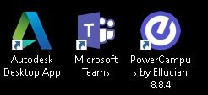
- You will also find the software you need (for example, PowerCampus, Teams) either on your desktop or within the Start Menu.

Configuring and connecting using VPN
You can only use this option on Keyano laptops. Read more on the section titled “Must Read - VPN vs VDI”
To configure and connect your VPN client:
- Start the “FortiClient Console”
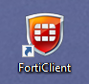
- You will see an option called “Configure VPN”
Fill the fields and ensure the checkboxes are checked (highlighted below)
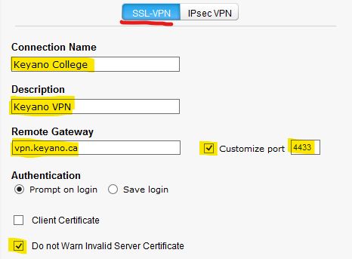
- Click Apply and Close
- Enter your Keyano Credentials and click connect.
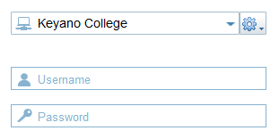
Contact ITS if you need assistance with the VPN

